InkDesktop Manual

Last updated: 30th March 2017

# About

InkDesktop is a windows application to allow easy usage of pen devices – signature pads, pen displays, pen tablets, and pen-enabled computers. It is currently supporting the latest Wacom devices as of the March 2017. The main capabilities include detecting of connected devices, capturing and saving of signature, screen saver for signature pad.

# Prerequisites

STU SDK 32-bit, Wintab (included in Wacom tablet driver), Admin access – for the http server to capture signature from browsers.

# Installation

Run the setup.exe, and follow through the defaults.

Default folder: C:\Program Files (x86)\Wacom Solution Partner\InkDesktop

* InkDesktop will not start automatically after installation. But it will start automatically after you restart the computer.

# Supported Devices

Wacom signature pads – STU-300, STU-430, STU-430V (USB mode), STU-500, STU-520, STU-530, STU-540

Wacom pen displays – DTU-1031, DTU-1031X, DTU-1141, DTU-1631, DTU-1651, DTU-1931, DTU-2231, DTU-2241

# Running InkDesktop

InkDesktop will run automatically every time windows start, and the user will be prompted for administrator access.

InkDesktop will reside in the Windows notification area, identified by the blue pen icon.

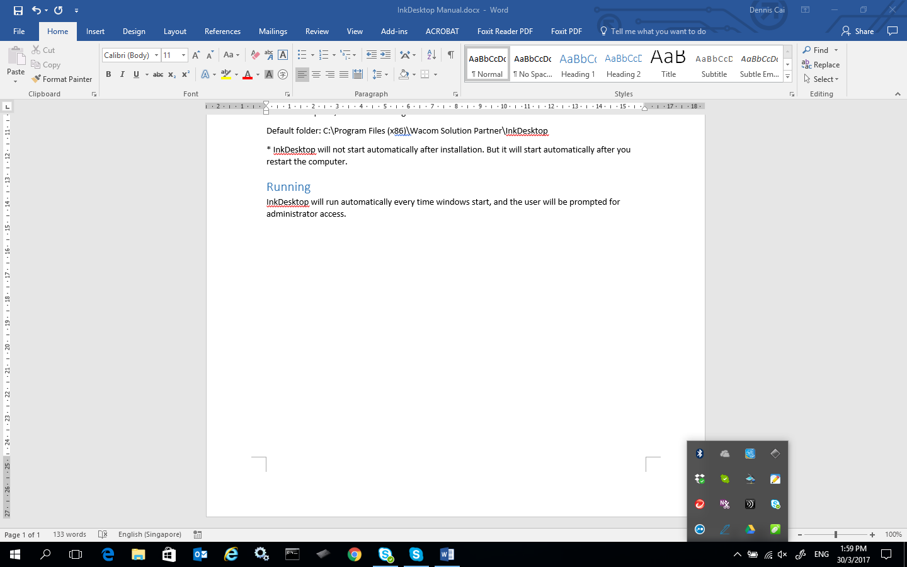

Clicking on the icon will show up the InkDesktop panel right above the windows notification area.

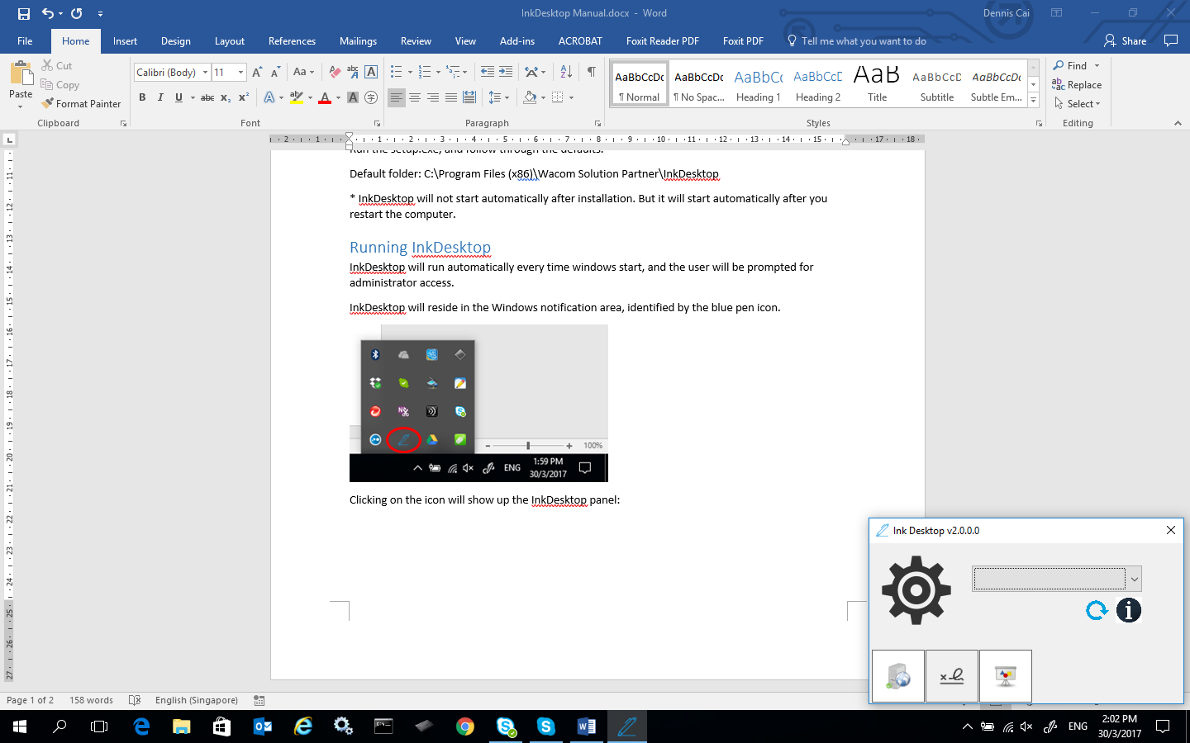

When a recognised device is plugged in, InkDesktop will show information of the device. If the device is not shown, clicking on the refresh icon  will prompt the software to scan for newly connected devices.

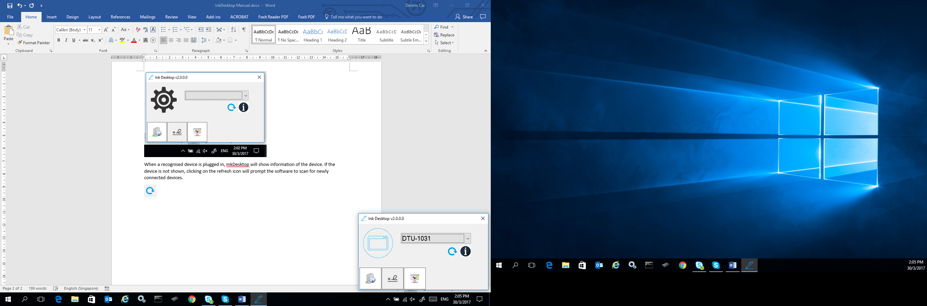

Features

1. Device information
2. Signature capture
3. Screen saver – for signature pads only
4. HTTP server, and sample applications – to enable signing on browser (Chrome)

## Device information

When a device is connected, click on the “I” icon  will display a window showing the information of the connected device.

*Note: The Connection ID is an arbitrary identification number provided by InkDesktop when a device is plugged in.

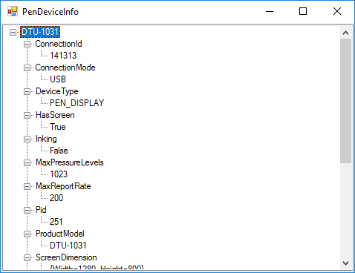

## Signature Capture

Click on the 2nd icon in the screenshot below to launch the signature capture window.



If a signature pad is plugged in, the window will adjust to the actual display resolution size of the connected signature pad.

User can choose which pen device to show the signature capture window. Click on the “Sign” button to display the standard signature capture screen. Then user can sign on the signature pad or directly on the pen display.

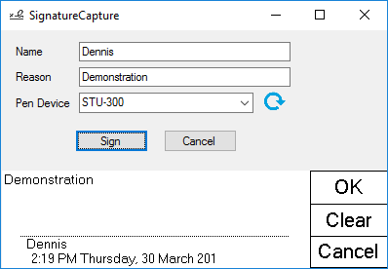

The name and reason are optional, and if provided, will appear in the signature capture screen.

After the signature is captured, right-clicking on it will show a context window to save the signature as a png file with pen data hidden steganographically in the pixels, or copied to the clipboard. The picture size will be enlarged if the amount of pen data is too numerous to be saved in the current image size.

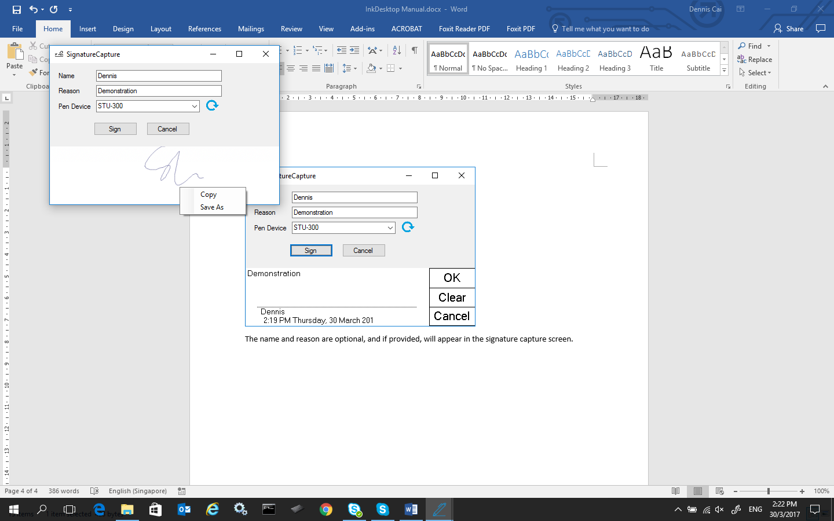

## Screen Saver for signature pad

This function will show images on the signature pad when the device is idle. Please disable the STU Display if you want to use this function.

Click on the 3rd icon in InkDesktop to activate the screen saver settings window.



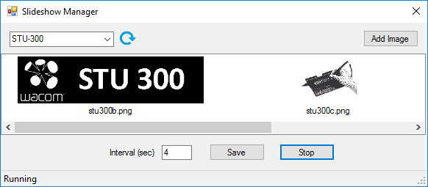

You can select the device, and add the image for each signature pad from here.

The default images are stored in the Slideshow folder in the installation folder. The actual setting is a JSON file – SlideShowSettings.json, found in the location where InkDesktop is installed. Default location will be C:\Program Files (x86)\Wacom Solution Partner\InkDesktop\SlideShowSettings.json.

## HTTP server, and sample applications



Right-click the icon to show the status, port number, and examples.

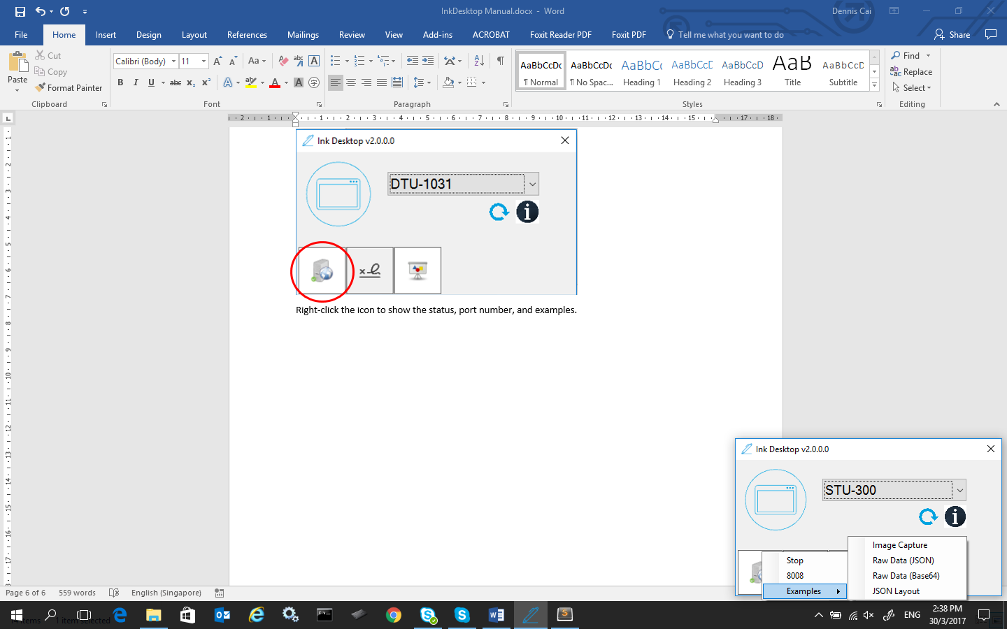

The default port is 8008. Web applications can call <http://localhost:8008/captureimage> to call a basic signature capture. It is better to entail a timestamp after the url to prevent lazy loading. Example as such:

function CaptureSignature() {

document.getElementById("imgSignature").src =

"http://localhost:8008/captureimage?" + new Date().getTime();

}You can refer to other examples if JSON data or base64 data is required. The JSON layout example shows how you can create a workflow of screens to show. The examples are in the TestSite folder in the installation folder.

Clicking on the port number (8008), will display a window to change the port number if 8008 is already taken by other programs.

